PRAC-5

1

AIM:

The aim of this program is to understand abstraction and polymorphism in Java.
It demonstrates how to create an abstract Shape class with an abstract area() method.
Different subclasses such as Circle, Rectangle, and Triangle calculate their areas differently.A Shape[] array is used to store different types of shapes together.
The program uses a single loop to calculate and display each shape's area.
It also calculates the running total and identifies the shape with the largest area.
This program helps understand runtime polymorphism through method overriding.

Code:

abstract class Shape {
abstract double area();
}

class Circle extends Shape {
double r;

Circle(double r) {
this.r = r;
}

@Override
double area() {
return Math.PI * r * r;
}
}

class Rectangle extends Shape {
double l, w;

Rectangle(double l, double w) {
this.l = l;
this.w = w;
}

@Override
double area() {
return l * w;
}
}

class Triangle extends Shape {
double b, h;

Triangle(double b, double h) {
this.b = b;
this.h = h;
}

@Override
double area() {
return 0.5 * b * h;
}
}

public class Main {
public static void main(String[] args) {

Shape[] arr = {
new Circle(5),
new Rectangle(4, 6),
new Triangle(8, 3),
new Circle(3)
};

double sum = 0;
double max = 0;

for (Shape x : arr) {
double a = x.area();

System.out.println("Area = " + a);

sum += a;

if (a > max) {
max = a;
}
}

System.out.println("Total area = " + sum);
System.out.println("Largest area = " + max);
}
}

Output:

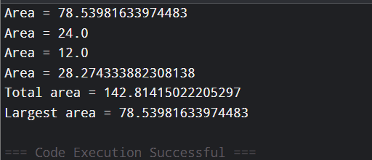

2

AIM:

to apply abstraction, inheritance, and polymorphism to media items.
It demonstrates an abstract Media class with a common title and late days.
Different media types such as books, DVDs, and magazines calculate late fees differently.
Each subclass overrides the lateFee() method according to its own fee rule.
A mixed Media[] array is used to store different types of media.
The program calculates and displays the late fee for each returned media item.
It also calculates the total late fees for the complete batch.

Code:

abstract class Employee {
String n;
int i;

Employee(String n, int i) {
this.n = n;
this.i = i;
}

abstract double monthlySalary();
}

class FullTime extends Employee {
double s;

FullTime(String n, int i, double s) {
super(n, i);
this.s = s;
}

@Override
double monthlySalary() {
return s;
}
}

class PartTime extends Employee {
double h;
double r;

PartTime(String n, int i, double h, double r) {
super(n, i);
this.h = h;
this.r = r;
}

@Override
double monthlySalary() {
return h * r;
}
}

class Intern extends Employee {
double st;

Intern(String n, int i, double st) {
super(n, i);
this.st = st;
}

@Override
double monthlySalary() {
return st;
}
}

public class Main {
public static void main(String[] args) {

Employee[] arr = {
new FullTime("A", 101, 50000),
new PartTime("B", 102, 80, 300),
new Intern("C", 103, 15000),
new FullTime("D", 104, 60000)
};

double total = 0;

for (Employee x : arr) {
double sal = x.monthlySalary();

System.out.println(x.n + " (ID: " + x.i + ") - Salary: INR " + sal);

if (x instanceof Intern) {
System.out.println("Note: This employee is an Intern.");
}

total += sal;
}

System.out.println("Total Salary: INR " + total);
}
}

Output:
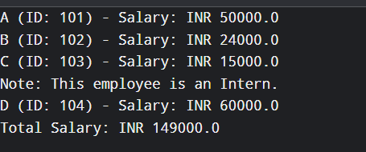

3

AIM:

To develop a Java program to fill placeholders in a given text template.
The program uses a regular expression to identify placeholders in the template.
Each placeholder is matched with its corresponding name in a parallel array.
The associated value is substituted for every supplied placeholder.
If a placeholder has no corresponding value, it is replaced with [?].
A StringBuilder is used to construct the final filled template efficiently.
The completed template is then displayed as the output.

Code:

abstract class Media {
String itemName;
int overdueDays;

Media(String itemName, int overdueDays) {
this.itemName = itemName;
this.overdueDays = overdueDays;
}

abstract double calculateFee();
}

class Book extends Media {

Book(String itemName, int overdueDays) {
super(itemName, overdueDays);
}

@Override
double calculateFee() {
return overdueDays * 2;
}
}

class DVD extends Media {

DVD(String itemName, int overdueDays) {
super(itemName, overdueDays);
}

@Override
double calculateFee() {
return overdueDays * 5;
}
}

class Magazine extends Media {

Magazine(String itemName, int overdueDays) {
super(itemName, overdueDays);
}

@Override
double calculateFee() {
return overdueDays * 1.5;
}
}

class Newspaper extends Media {

Newspaper(String itemName, int overdueDays) {
super(itemName, overdueDays);
}

@Override
double calculateFee() {
return overdueDays * 1;
}
}

public class Main {
public static void main(String[] args) {

Media[] collection = {
new Book("Java Programming", 3),
new DVD("Avatar", 2),
new Magazine("Tech Today", 4),
new Newspaper("Daily News", 5)
};

double grandTotal = 0;

for (Media item : collection) {
double charge = item.calculateFee();

System.out.println(
item.itemName + " - Late Fee: INR " + charge
);

grandTotal += charge;
}

System.out.println("Total Late Fees: INR " + grandTotal);
}
}
Output:

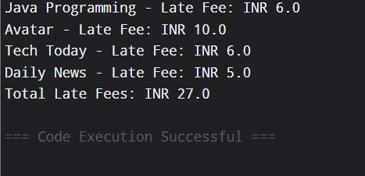

Key Questions :

1. Difference between an abstract class and a concrete class?

An abstract class is a class declared with the abstract keyword and cannot be directly instantiated. It can contain both abstract methods and fully implemented methods and is mainly used as a base class for other classes. A concrete class, on the other hand, is a normal class that provides complete implementations of its methods and can be directly instantiated to create objects. In simple words, an abstract class acts as a blueprint, while a concrete class represents the actual object.

2. What is dynamic method dispatch (run-time polymorphism)?

Dynamic Method Dispatch (Run-Time Polymorphism) is a mechanism in Java where the method that gets executed is decided at run time, based on the actual object being referred to rather than the reference type. It occurs when a parent class reference refers to a child class object and the child class overrides a method of the parent class. This allows the same method call to perform different actions depending on the object.
Example: Animal a = new Dog(); and a.sound(); will call the sound() method of Dog if Dog overrides it.

3. What does the super keyword do in a subclass constructor?

The super keyword in a subclass constructor is used to call the constructor of the parent class. It is mainly used to initialize the common variables inherited from the parent class. The super() call must be the first statement in the subclass constructor. For example, super(name, id); calls the parent constructor and initializes the shared name and id values.

